Title | Health & Safety for Contractors
Document Reference | CEHS062
Responsible Person | Hayley Hurdle
Date Last updated | 11 January 2017
Revision Number | V1.1
Status | Active
Location | Quality (Q:)

GENERAL
The Contractor will adhere to the requirements of the Health and Safety at Work etc Act 1974, Environmental Protection Act 1990 and all relevant Acts, Regulations, Codes of Practice, current industry best practice and the Safety, Health and Environmental Policies of Chloros Environmental.

The Health & Safety at work Act 1974 (hereinafter referred to as “The Act”) and the EU Directive 89/391 - OSH "Framework Directive" places onerous responsibilities on employers in respect of not only their own employees, but also persons not directly employed by them but who may be affected by the way their business is conducted. It is therefore in both parties’ interest to ensure that certain ground rules are applied and that we do our utmost to ensure that they are enforced.

It is the objective of these instructions to outline, in general terms, what the company expects and appropriate methods of achieving the necessary standards.

DEFINITIONS
In these instructions, “Company” means Chloros Environmental Ltd. “Contractors” means any company, firm or person legally undertaking work or services of any description on the company’s premises to the company’s requirements. “Company Manager” means any person authorised as agent or otherwise by the company to act on its behalf in dealings with a contractor. “The Act” means the Health & Safety at Work Act 1974 (or any consolidating or re-enactment thereof).

These instructions shall be deemed to be incorporated into any relevant contract for work on behalf of the company and shall prevail in the event of any inconsistency between them and any other term of the contract.

INTRODUCTION
These instructions have been devised to ensure that work on the company’s premises is carried out in a manner, which is safe for those engaged in the actual work and those in the vicinity. These instructions shall not in any way limit the obligation of the contractor or of his employees or sub-contractors under the Act and any other relevant legislation. These instructions shall not be taken to impose any additional duties or greater responsibility on the company other than that required by the above Act or any other relevant legislation.

INSURANCE
The contractors must ensure that they are insured and kept insured with a reputable insurance company. At a prudent level of cover against any employee’s liability claim and any liability arising out of any loss, damage or injury suffered by the company or its employees/third party whether as a result of the Contractor’s failure to comply with the terms of the instructions or otherwise and shall indemnify and keep indemnified the company against any liability arising out of such loss, damage or injury.

CONDUCT
The contractors must not carry out or allow any work to be carried out which may cause risk to the health, well-being or safety of any person, or damage to property unless the contractor has taken all reasonable precautions. In addition to any specific requirements contained in any documentation on which the contractor has been invited to tender for the work.

The Management has the right to stop work, if unsafe practices are observed, and will notify the contractor’s site representative to order such stoppage and the contractor shall not recommence work until the situation has been completely remedied. The company will not accept responsibility for increased costs arising out of such action, which costs shall be met by the Contractor.

ACCIDENTS
The company will be responsible for the statutory recording and reporting of all accidents, injuries and dangerous occurrences involving the contractor’s and sub-contractor’s employees and plant, equipment and machinery. The Contractor must provide information of these incidents to the Company Manager/Company Health & Safety Advisor to enable the company to fulfil its statutory obligations and those of its insurers.

Emergency exits and firefighting access routes must not be blocked and fire alarms and firefighting equipment must not be obstructed or put out of action. If certain work cannot be carried out without causing such conditions, the Company Manager must be consulted and his consent obtained before starting work.

The accumulation of combustible materials or flammable liquids must be avoided, such materials being removed from site at the end of each day to a safe distance from buildings.

CONSTRUCTION SAFETY
Before leaving work, scaffolding must be left secure, all loose tools and materials secured or brought down to ground level and suspended loads lowered to the ground.

Plant machinery or equipment being installed, modified, repaired or removed must be properly guarded and left in a safe condition when unattended.

Live equipment, electrical circuits must be properly isolated or protected in accordance with the relevant legislation, Warning notices posted by the Contractor.

Overhead work must not start until the Company Manager has been informed and adequate precautions taken by the Contractor to ensure the safety of persons and property below, including warning notices posted by Contractor

Special attention must be paid to roofs made of fragile materials and crawling boards must be used where appropriate. On all roof work, the Contractor must maintain liaison with Management to establish a safe means of access and a procedure for cleaning work areas below. The Contractor must only employ experienced operatives on roof work. The Contractor must advise the Health & Safety Executive of all contracts that include work on roofs lasting more than six weeks.

Please note, the Company have a strict policy of wearing hi-vis vests, safety specticales and steel toed boots when working in and around the transfer station. The layout of the transfer station is as below:

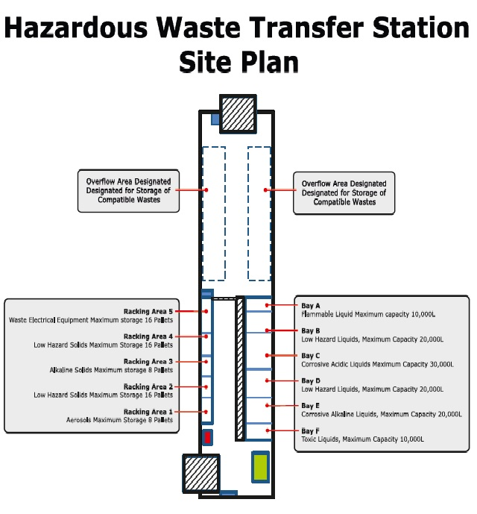

When in any area of the Landlord, steel toed shoes/boots, a high-vis jacket/vest and safety spectacles must be worn. Failure to comply with this may mean you are refused entry to the Company’s premises.

PERSONAL PROTECTIVE EQUIPMENT
The Contractor will be responsible for providing and, as far as is reasonably practicable, enforcing the use by its employees and sub-contractors at all relevant times of any personal protective equipment required to be used in conformity with any relevant statutes, regulations or codes of practice and company rules in force at that time.
Personal protective equipment will not be supplied by the Company, at any time, to any contractor or sub-contractor.

PLANT MATERIALS AND EQUIPMENT
During the work, the Contractor will be responsible for the control and safety of all plant, materials, equipment, machinery and appliances to be used on the Company’s premises and for their conformity to all relevant statutes, regulations or codes of practice in force at that time.

The contractor will be responsible for ensuring that its workforce and that of any sub-contractors are properly trained in the use of all plant, materials, equipment, machinery and appliances dangerous or flammable substance.

The Contractor must not make use of company electricity, gas, water, compressed air supplies or other services without first obtaining permission from the Company Manager. Whenever possible, portable electronic equipment should utilise a 110-volt supply taken from a centre-tapped transformer, where this is not possible, a differential safety unit must be used. Cables supplying portable equipment must be constructed, used and maintained in accordance with the Electricity at Work Regulations 1989.

NEW EQUIPMENT
The portable equipment must be packed to ensure safe transportation and sealed to ensure that it cannot be tampered with by unauthorised persons. A certificate confirming compliance with Electricity at Work Regulations 1989 should be issued with the equipment. Equipment delivered to the site may only be unpacked by the installing “expert” in the presence of Management.

In view of possible interference with underground electrical cables, drains, water and gas mains, etc. excavation work must be started after consultation with the Company Manager; that notwithstanding, the Contractor will remain responsible for any ensuring damage.

FIRE PRECAUTIONS
The contractor shall be responsible for the fire precautions, providing any necessary firefighting equipment in designated premises. In the event of fire, the Contractor shall comply with Company instructions and fire procedures.

The Contractor shall ensure strict observance by his workforce and the workforce of any sub-contractors of all rules and instruction issued by the Company with a view to complying with statutory requirements relating to Health & Safety. The Company operates a no smoking policy in all its units and buildings. There are designated smoking areas around site.

The Contractor must inform the Company Manager before any “hot work” involving the use of welding equipment, blowlamps, open flame or grinding undertaken anywhere on the premises. In certain areas specified by the Company or as required by the statute or regulations flameproof equipment must be used. Methods of working must be agreed with the EHS Manager who will issue a written permit to undertake the work when required.

Excavation must be properly fenced off or covered and, where necessary, protected by suitable warning lamps illuminated during the hours of darkness or poor visibility. Debris must be removed progressively and not allowed to obstruct gangways, etc. Mud must not be allowed to remain on roadways passageways or gangways.

If the work entails removing thermal insulation materials, the Contractor must ascertain if they contain asbestos materials. If they do, the proposed method of work must be discussed with Management to ensure that the system of work adopted adequately protects the health and safety of all personnel on site. Any work with asbestos must, at all times, comply with any regulations and codes of practice relating to this material.

WASTE MANAGEMENT
Contractors have a responsibility to manage any waste from The Company’s site appropriately, minimising the amount of waste produced in the first place and reusing or recycling wherever possible. Any contractor removing waste from site must be licensed to do so, and a copy of their Waste Transfer Licence must be on file prior to any removal from site. A Waste Transfer consignment note must be given at the time of removing the waste from site. Authorisation must be obtained by the Group H&S Advisor to use company waste facilities.

POLLUTION CONTROL
Contractors should reduce the risk of a pollution incident through taking the following precautions:

- Wherever possible, select materials which are the least environmentally-damaging.
- Plan carefully to minimise the volume of hazardous chemicals brought onto and stored on-site.
- Keep a folder on-site with COSHH sheets for any chemicals being used.
- Ensure that any hazardous chemicals used are stored upright, in sealed containers, away from drains and off the floor.
- If necessary, bring protective equipment and spill kits with you so you are adequately prepared in the case of a spill.
- Ensure that all hazardous chemicals are removed from site once your work is complete.

DISCIPLINE
The Contractor shall ensure strict observance by his workforce and the workforce of any sub-contractor to these instructions and any rules and instructions issued pursuant thereto.
Serious breaches of these instructions may result in the individual or Contractor concerned being asked to leave the Company’s premises.

I, the undersigned, have read, understood and agree to comply with the above instructions and understand that failure in my duties in respect of these instructions will result in any works undertaken being halted and contractors/sub-contractors being removed from site.

COMPANY NAME:
ADDRESS:
SIGNED:
NAME:
DATE:

